Introduction :

In this component of the Assignment we tried to understand the key steps in the implementation of a neural network.

We came to about feed forward steps of a neural network which is useful in prediction of output and error calculations and backward propagation of Neural Network which is helpful in calculation of partial derivatives of error function with respective weights. For updating weights accordingly for a good predictive model.

Methodology:

We have implemented a 3 layered neural network (1 hidden layer ) which has desired nodes in hidden layer,four nodes in front layer(i.e, input layer),one node in final layer (output layer).we used tanh as activation for the first layer and sigmoid for next layer(as it is a binomial classification ).

We can choose activation functions based on our requirements.we chose tanh function as its outputs lie from -1 to 1 so that we have a good gradient from -1 to 1 for the sigmoid function to separate thenfine.

Here calculation of backward gradients are key we took tanh and sigmoid functions we have to take gradients as

For sigmoid: ypred-y

For tanh : dot product(W2.trans,dZ2)\*(1-ypred\*ypred)

Here ypred is for each layer respectively

Optimization technique used is gradient descent.

Results:

For 7 hidden nodes and 40000 iterations,eta=5

test data is which we split from given set(20%)

ACC 90.06849315068493

F-Sc 0.9102167182662538

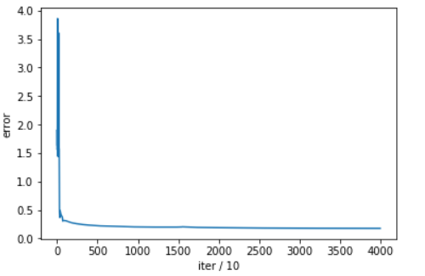

#We have scaled all the features (inputs) to range from 0-1.This is giving better results because sigmoid can differentiate values if x is in the vicinity of 0.which is why we used tanh as an activation function in the first layer